|  |  |
| --- | --- |
| WEST LONDON WASTE AUTHORITY |  |
| Report of the Head of Service Delivery & Operations Manager | 22 March 2024 |
| **Contracts and operations update** | |
| SUMMARY This report provides an update on the Authority’s waste treatment arrangements and procurements. The key points are:   * Contracts and operations are performing well * The crane replacement programme is scheduled to begin on 1 April and a contingency plan has been developed and shared * Much of the HRRC Improvements fund is unspent, and a proposal is included for how to allocate the remaining money. | |
|  | |
| **RECOMMENDATION(S)** The Authority is asked to:   1. Note this report 2. Approve remaining HRRC improvement funds to be ringfenced by each Borough to deliver improvements identified by the best practice report. | |

1. **Introduction**

This report provides an update on WLWA’s existing contracts and operations for managing West London’s waste.

1. **Contract performance**

The performance of the Authority’s key operational contracts is explained in the following table.

| **Contractor** | **Service** | **Value (per year)** | **Operations** | | **Financial risk (RAG)** |
| --- | --- | --- | --- | --- | --- |
| RAG | Description |
| WLERL, operated by Suez | Residual waste  300,000 tonnes/yr | £35m | G | Good performance at SERC and the two rail linked transfer stations.  Replacement of the cranes is scheduled to take place on 1 April. | G |
| Viridor (Lakeside) | Residual waste  90,000 tonnes/yr | £14m | G | The contract is operating well. | A |
| BioCollectors | Food waste  All Boroughs’ food waste | £0.4m | G | The contract is operating well. | G |
| West London Composting | Garden waste  All Boroughs’ garden waste | £1.5m | G | The contract is operating well. | G |
| N+P | Dry mixed recycling  From Ealing and Brent | £3m | G | The contract is operating well. | G |
| Waste-a-Way Recycling | Transporting waste & recyclables using bulk haulage vehicles. | £1m | G | The contract is operating well. | G |
| Suez | Transporting waste & recyclables using RoRo vehicles. | £0.5m | G | The contract is operating well. | G |

WLERL Operations

Severnside Energy Recovery Centre (SERC) and the two rail linked transfer stations at Brentford and Ruislip are operating well.

Site layout and process changes at Ruislip (Victoria Road) have seen on-site waiting times continue to stay low. A system is currently being setup to measure off-site queuing times using new Automatic Number Plate Recognition (ANPR) cameras on the access roads. Boroughs have been asked to provide their own queuing time data in the meantime.

The replacement of the bunker cranes at Victoria Road is due to start on 1 April and last for approximately 20 days. During this time, it will not be possible to load waste into the rail haulage containers via the compactors, so the layout of the site will be temporarily changed as below to allow it to function purely as a road transfer station.

Waste inputs will be reduced with Ealing sending most of its waste to Transport Avenue during this period, Hillingdon delivering most of its waste to Lakeside, and a larger proportion of bulky HRRC waste going to Transport Avenue. Some staff will be temporarily transferred from Victoria Road to Transport Avenue where a second shift will be run during this period of increased throughput. Suez’s Hayes transfer station, which is now fully operational, will act as the main contingency site during the works, with further alternative sites also lined up. Borough heads of service have been consulted on these plans.

Fires continue to pose a major risk to the transfer stations, although the frequency of fires is currently low, which is normal for this time of year. A cross-Borough, cross-department task and finish group focusing on operational solutions to fires has been established to identify mitigations ahead of the peak-fire season of mid-spring to mid-autumn.

In order to reduce carbon, electric waste shredders are being trialled at the transfer stations.

1. **Procurements**

New contracts have been awarded to:

* WasteCare – a producer compliance scheme which will collect and process waste electrical and electronic equipment from west London HRRCs/transfer stations. The contract is for a three year term (with the option to extend for two one-year periods) and will begin on 1 April 2024. WasteCare’s tender demonstrated a strong ability to meet our service requirements and increase reuse of waste electricals.

1. **Abbey Road HRRC and Waste Transfer Station (WTS)**

Abbey Road HRRC and WTS is managed by WLWA, and the HRRC is run on behalf of Brent Council.

The HRRC continues to deliver a high diversion (from residual waste) rate of 78%, and strong budget position (see Section 7). The WTS continues to operate well with the additional street cleansing waste delivered by Brent Council. This arrangement is saving Brent over £100,000 a year in waste transfer costs.

Site staff have observed cracks in a section of the waste transfer station’s concrete structure and initial investigations led to the cessation of activities on and below this area. Detailed investigations are now taking place and temporary operational arrangements are underway. Most of the transfer station remains open and operational as normal.

1. **Richmond’s sites: Townmead Road HRRC/WTS and Central Depot**

WLWA currently provides waste operations oversight at Richmond’s two waste sites.

A health and safety incident occurred at Central Depot, where an operative’s foot was run over by mobile plant. The operative was uninjured and the incident was reported to LBRuT officers.

A Service Level Agreement (SLA) for the on-going operational management of the sites is nearing completion.

1. **Operations Manager**

A new permanent Operations Manager has started, following nine months of interim cover. The new Operations Manager will deliver H&S best practice and cost and carbon savings for Boroughs by placing renewed focus on developing key cross-Borough stakeholder groups, supporting the delivery of improvements at HRRCs, and increasing the efficiency of the Authority’s waste flows.

1. **HRRC improvement programme**

In the 2022/23 budget, £200,000 per Borough (£1.2m total) was set-aside for Boroughs to deliver improvements at HRRCs. Boroughs with a diversion performance of 40% or greater were permitted to spend the money as they chose as long as the improvements delivered against Environment and Director priorities for HRRCs. Boroughs performing below 40% needed to ensure that 40% was exceeded by the end of the year in order to retain the funds.

£0.94m was unspent at the end of 2022/23, and it was agreed that this could be rolled over to 2023/24 subject to new performance targets and a 50% diversion target was set by Environment Directors. As we approach the end of 2023/24, £763,000 remains unspent, of which £597,000 is planned spend, leaving £165,000 unallocated budget.

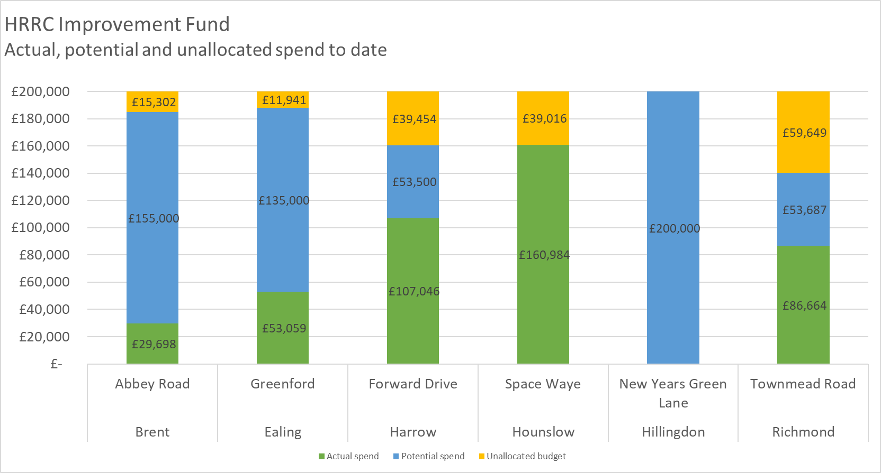

Diversion of materials from residual waste is a key performance indicator for HRRCs. The chart below shows some improvements since the project started at four of the HRRCs, but decreases in performance at two (Ealing’s and Hounslow’s). There remains a significant gap between the lowest and highest diverting HRRCs of over 40 percentage points.

Whilst diversion rate is a useful indicator for understanding how well a site reuses and recycles, residual waste is the indicator that most accurately reflects the cost and carbon burden of an HRRC to west London taxpayers. The chart below shows that residual waste per household varies significantly between the sites. Hillingdon, Harrow and Hounslow’s sites each have relatively low diversion rates and high volumes of waste going through the HRRC, which results in high quantities of residual waste per household. The cost of transporting and disposing of this material is borne by all six Boroughs as part of the Fixed Cost Levy and is apportioned based on Council Tax Band D properties.



If all Boroughs’ kg per household were equal to the lowest Borough, around £1.9 million per year could be saved. Conversely if all Boroughs’ kg per household were equal to the highest, annual costs would increase by around £5.5 million.

The Abbey Road site has demonstrated how it’s possible to maintain very high performance and continue to improve whilst reducing cost at the same time. Major improvements since 2020 include:

* Creating covered storage areas for reusable items including bikes and furniture
* Two new workshops for repairing items, including laptops and bikes
* Nine new separate collections for previously non-recycled items
* Improved look and feel with quality signage, newly painted bins and showcasing upcycled items
* A non-recyclables checkpoint where customers are helped to separate reusable and recyclable items from their waste, educating them ahead of their next visit
* A data-based approach with a move to using tablets to manage customer bookings and survey site users, providing valuable insights about waste habits and behaviours. This helped lead to a new high quality bulky materials home collections service for Brent.

During this time, and following investment during the pandemic, the site’s budget has continued to improve (see chart), thanks to control of costs whilst increasing income from sale of recyclables and income from commercial waste on-site.



There are a number of ways in which the remaining HRRC improvement funds can be allocated, and a decision is needed before the end of the current financial year.

1. Return the money to Boroughs via the disbursement of reserves (apportioned by Band C households)
   1. All unspent money, or
   2. Only unallocated and unspent money
2. Return each Borough’s remaining balance to them directly
   1. All unspent money, or
   2. Only unallocated and unspent money
3. Roll over the remaining money to 2024/25 but with strong performance targets attached.
   1. Ringfence the unspent balance for each Borough, or
   2. Put the whole unspent balance into a central pot for all Boroughs to access.

The analysis above indicates that there is much more to do regarding HRRC improvements, and many Boroughs have plans for how they would like to spend the remaining money. Therefore the recommendation is to adopt Option 3a and ringfence the remaining balance for each Borough.

However, the current approach has not delivered a major uplift in performance and the delivery of initiatives has been slow, so a new approach is needed.

WLWA will work with the Boroughs define what a best performing HRRC is, and exactly how and when each Borough’s HRRC can achieve this level. We will do this by:

* **Providing training**: A visit to a best practice HRRC (out-of-area) for Members and key officers.
* **Defining best practice**: A report with a specification for a ‘best performing’ HRRC service, clear performance targets and options for delivery - presented to the Authority in June
* **Launching a procurement** for a new HRRC service
* **Defining in-year improvements** for all Boroughs
* **Establishing commercial arrangements** for participating and non-participating Boroughs

The remaining HRRC improvement funding will be ringfenced to the Boroughs for delivering the in-year and the longer-term performance improvements identified by the HRRC best practice report.

1. **Financial Implications**

|  |  |
| --- | --- |
| **Section** | **Financial Implications** |
| West London Residual Waste Services contract | The upgrade to the cranes at Victoria Road transfer station costs £4m and will be financed by the Contractor. |
| Viridor (Lakeside) | The cost of managing 90,000 tonnes of residual waste through this contract is projected to be 3% higher than the budgeted amount due to the impact of inflation. |
| Procurements | The waste electricals arrangement enables the potential for revenue in the form of a rebate generated from LDA (Large Domestic Appliances) and funding for improvements of up to £30,000. The current arrangements deliver income for LDAs, but not improvement funding, so the new contract will deliver an improved income position. |
| Abbey Road HRRC and Waste Transfer Station (WTS) | The costs of repairs to the waste transfer station’s concrete will be determined through forthcoming studies. Budget has been assigned for reactive maintenance, for repairs such as these. Work is ongoing to determine if the costs can be claimed back through insurance. |
| Richmond’s sites: Townmead Road HRRC/WTS and Central Depot | WLWA’s staffing costs to support the sites are covered as part of a Service Level Agreement with the London Borough of Richmond upon Thames (LBRuT). |
| Operations Manager | The Operation Manager role has been included within the budget. |
| HRRC Improvement Project | The HRRC improvement fund is worth £1.2 million (£0.2 million per Borough). £0.77m was unspent at the end of 2022/23 and rolled over into 2023/24. As we approach the end of 2023/24, £706,000 remains unspent, of which £598,000 is committed spend, leaving £108,000 unallocated and uncommitted.  The best practice study will help determine the scale of savings that can be achieved from best practice operations, along with the costs required to get there. |

1. **Staffing Implications**

None.

1. **Legal Implications**

Under the existing service level agreement, LBRuT remains legally responsible for health and safety compliance at its Townmead Road and Central Depot sites.

1. **Impact on Carbon reduction**

Replacing the cranes at Victoria Road will speed up tipping times, increasing the efficiency of the Boroughs’ collection services and saving carbon.

1. **Impact on Environment Directors Priorities**

|  |  |
| --- | --- |
| **Priority** | **Key points raised within this report** |
| Bringing residents with us | HRRCs are a key interface with residents. The best practice study will determine the extent to which this interface can be best used. |
| Sustainable decision making | N/A |
| Climate adaptation and decarbonisation | Electric shredders at the transfer stations reduce the carbon impact of the operation.  Identifying fire prevention measures is a key climate change adaptation. |
| Dealing with financial challenges whilst delivering on climate change | Investments in the cranes at Victoria Road will save Boroughs costs and carbon through reduced tipping times and more efficient collection operations. |

1. **Impact on Joint Municipal Waste Management Strategy**

The framework of a joint plan for 2030 to be developed by WLWA and Boroughs was agreed in March 2022 and is shown below.



The HRRC improvement project will deliver reduce waste with more reuse, and will form part of the Capture Systems 2030 plan.

1. **Impact on statutory, national and London targets**

Improvements at HRRCs help towards the target of 65% recycling by 2035 (2030 in London).

|  |  |  |
| --- | --- | --- |
| Contact Officers | Tom Beagan, Head of Service Delivery  [tombeagan@westlondonwaste.gov.uk](mailto:tombeagan@westlondonwaste.gov.uk) | 01895 545516 |